PYTHON SOURCE CODE :
from langchain.tools import tool
from langchain.agents import (
AgentExecutor,
create_tool_calling_agent
)
from langchain.prompts import ChatPromptTemplate
from langchain_ollama import ChatOllama

# =====================================
# TOOL 1 - ATTENDANCE
# =====================================

@tool
def attendance_calculator(
total_classes: int,
attended_classes: int
):
"""Calculate attendance percentage and exam eligibility."""

percentage = (
attended_classes / total_classes
) * 100

status = (
"Eligible for Exam"
if percentage >= 75
else "Not Eligible for Exam"
)

return (
f"Attendance Percentage: {percentage:.2f}%\n"
f"Exam Status: {status}"
)

# =====================================
# TOOL 2 - RESULT
# =====================================

@tool
def result_calculator(
mark1: float,
mark2: float,
mark3: float,
mark4: float,
mark5: float
):
"""Calculate average marks, grade and pass/fail status."""

average = (
mark1 +
mark2 +
mark3 +
mark4 +
mark5
) / 5

if average >= 90:
grade = "A"
elif average >= 75:
grade = "B"
elif average >= 60:
grade = "C"
else:
grade = "D"

status = (
"Pass"
if average >= 50
else "Fail"
)

return (
f"Average Marks: {average:.2f}\n"
f"Grade: {grade}\n"
f"Result: {status}"
)

# =====================================
# TOOL 3 - FEE BALANCE
# =====================================

@tool
def fee_balance_calculator(
total_fee: float,
amount_paid: float
):
"""Calculate pending fee amount."""

pending = total_fee - amount_paid

return (
f"Pending Fee Amount: ₹{pending:.2f}"
)

# =====================================
# TOOL 4 - LIBRARY FINE
# =====================================

@tool
def library_fine_calculator(
delayed_days: int
):
"""Calculate library fine amount."""

fine = delayed_days * 5

return (
f"Library Fine Amount: ₹{fine}"
)

# =====================================
# TOOL 5 - HOSTEL FEE
# =====================================

@tool
def hostel_fee_calculator(
monthly_fee: float,
months_stayed: int
):
"""Calculate total hostel fee."""

total = monthly_fee * months_stayed

return (
f"Total Hostel Fee: ₹{total:.2f}"
)

# =====================================
# BONUS TOOL
# =====================================

students = {
"101": {
"name": "Kirito",
"department": "Mechatronics"
},
"102": {
"name": "Akhil",
"department": "CSE"
}
}

@tool
def student_information(
student_id: str
):
"""Retrieve student details using student ID."""

if student_id in students:
return str(students[student_id])

return "Student not found."

# =====================================
# TOOLS
# =====================================

tools = [
attendance_calculator,
result_calculator,
fee_balance_calculator,
library_fine_calculator,
hostel_fee_calculator,
student_information
]

# =====================================
# MODEL
# =====================================

llm = ChatOllama(
model="qwen3.5:latest",
temperature=0
)

# =====================================
# PROMPT
# =====================================

prompt = ChatPromptTemplate.from_messages(
[
(
"system",
"""
You are an AI College Assistant.

Always use tools whenever calculations are required.

Use one or more tools if needed.

Return clear answers.
"""
),
("human", "{input}"),
("placeholder", "{agent_scratchpad}")
]
)

# =====================================
# AGENT
# =====================================

agent = create_tool_calling_agent(
llm=llm,
tools=tools,
prompt=prompt
)

# =====================================
# EXECUTOR
# =====================================

agent_executor = AgentExecutor(
agent=agent,
tools=tools,
verbose=True
)

# =====================================
# TEST QUERY
# =====================================

response = agent_executor.invoke(
{
"input": """
I attended 80 classes out of 100.
My marks are 90, 85, 88, 92 and 95.
My course fee is 60000 and I paid 45000.

Provide:
1. Attendance Status
2. Grade
3. Pending Fee
"""
}
)

print("\nFINAL ANSWER:\n")
print(response["output"])

OUTPUT SCRENNSHOT OF ALL THE TEST CASES :
Multi tool call in a single prompt :
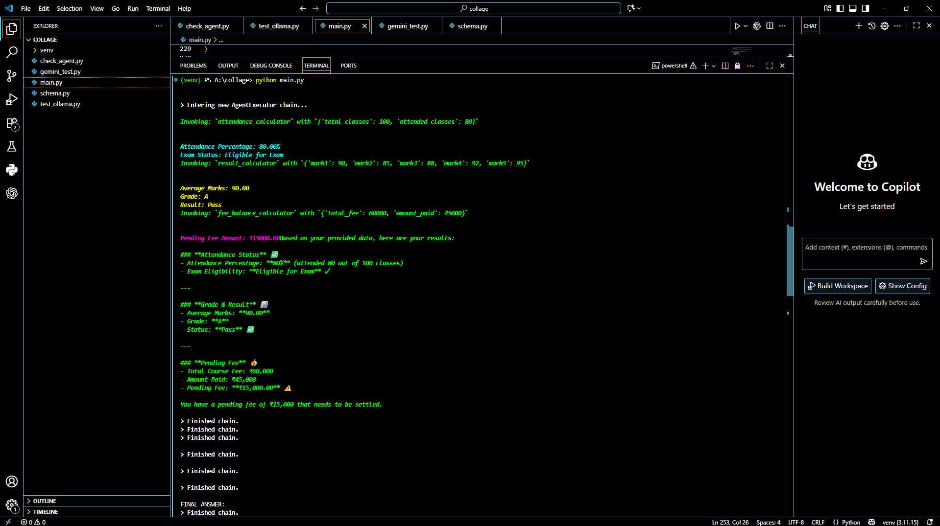

Attendance tool call :

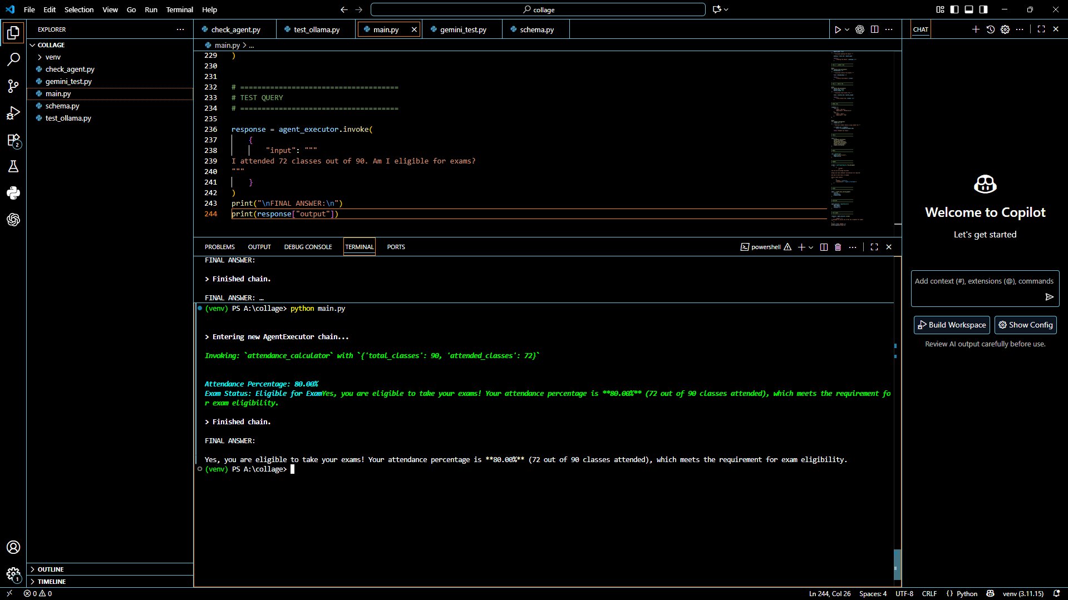

Result calculator :

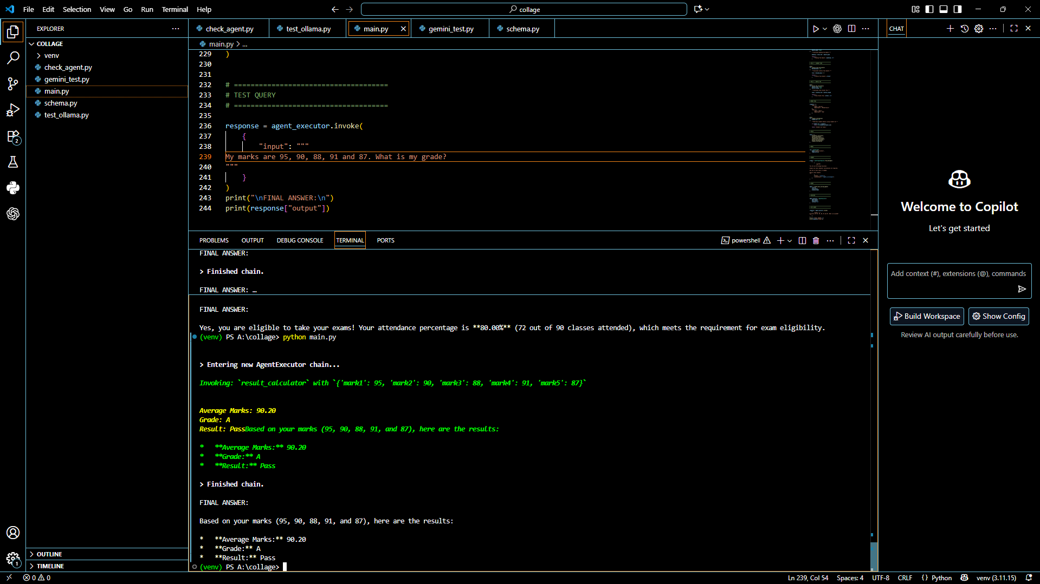

Fee balance calculator :
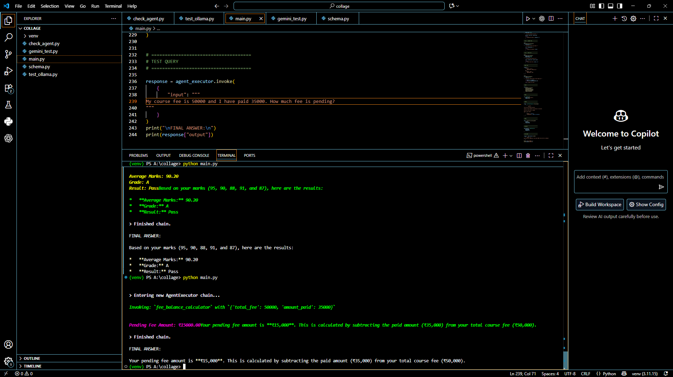

Library fine calculator
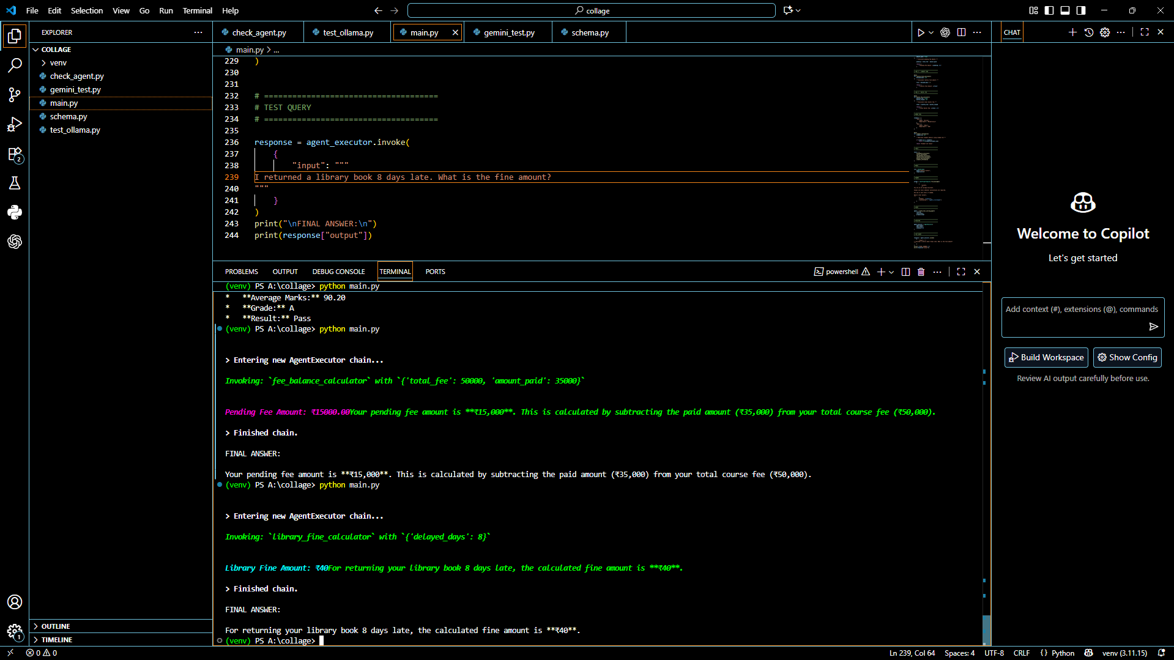

Hostel fee calculator
